**SNIATM Swordfish Datadog Sample Integration User Documentation**

Contents

Introduction: 1

Purpose 1

Overview: 1

Events 1

Dashboards 1

Metrics 2

Dashboard 2

Graph Editor: 3

Dashboard Screens: 4

# Introduction:

The Datadog Agent is a piece of software that runs on your hosts. Its job is to faithfully collect events and metrics and bring them to Datadog on your behalf so that you can do something useful with your monitoring and performance data. The Datadog Agent is open -source, view the source code on GitHub for Agent v5 and Agent v6. To see all changes between Agent v5 and v6, consult our dedicated changes documentation.

Swordfish dashboard collect all the metrics and show the capacity data in a graphical representation.

Purpose:

Understanding about data dog Dashboarding, usage and functionality.

# Overview:

Events:

The Event Stream is based on the same conventions as a blog:

* Every event in the stream can be commented on.
* Great for distributed teams and maintaining the focus of an investigation.
* You can filter by: user, source, tag, host, status, priority, incident

Dashboards:

Dashboards contain graphs with real-time performance metrics

* + Synchronous mousing across all graphs in a screenboard.
  + Vertical bars are events in the context of the metric.
  + Click & drag on a graph to zoom-in on a particular time-frame.
  + As you hover over the graph the event stream moves with you.
  + Display by zone, host, or total usage.

Metrics:

Custom metrics generally refer to any metric that you send using statsd, DogStatsD, or through extensions made to the Datadog Agent. Some integrations can potentially emit an unlimited number of metrics that can also count as custom, further details on which standard integrations emit custom metrics.

Dashboard:

Dashboard appears at left menu of Datadog home page as shown in figure below . No installations required for Datadog dashboard. We just need to select type of dashboard i.e.. Screenboard (or) Timeboard.

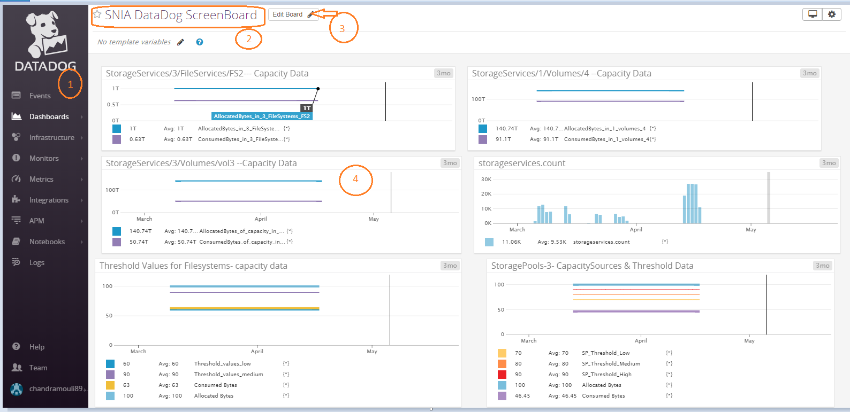

Fig1:- Main Dashboard

1. Menu-Bar.
2. Dashboard Title.
3. Edit Button of Dashboard.
4. Graph view.

## Graph Editor:

* + User can edit the graph and change the data and visualization.

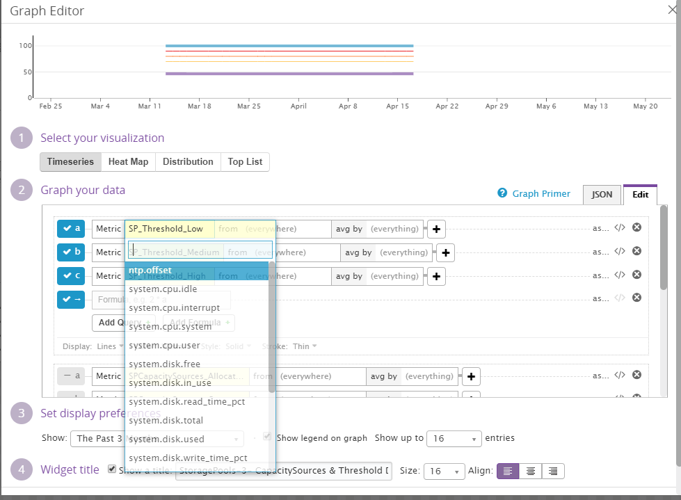

The graphing editor has three tabs:

* Share: Allows you to embed the graph on any external web page. (Note: The share tab is only available on Timeboards.)
* JSON: The more flexible editor, but it requires knowledge of the graph definition language to make use of it.
* Edit: Default tab that allows you to use a GUI to select the graphing options.

## Dashboard Screens:

1🡪Below figure shows capacity data in FileServices .

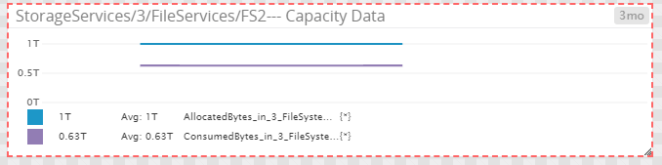

2🡪 Capacitydata with Threshold values.

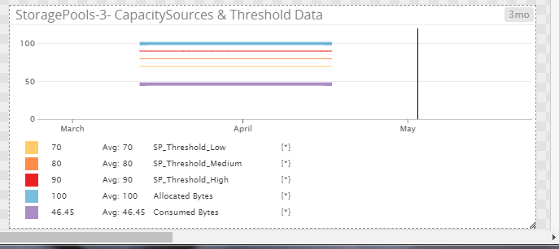

The same way to display all the storage services dashboard in data dog and monitoring the capacity every time with periodical schedule.